**SOP Branch Cash Sales**

**Issued Date: 07-01-15**

This is for reconciling previous day sales activity. (i.e. on 12/12/2014 you would reconcile for 12/11/2014 activity)

1. Run OERR in GUI (screen shots attached)
   1. New One-Time

**Customer # Listing:**

900000- Employee Sale

900001- PDX

900002- Woodinville

900005- Salem

900006- Hillsboro

900007- Kingdom (Seattle)

900009- Clackamas

9000010- Tacoma

900012- Eugene

900013- Medford

900018- Ridgefeild

900017- West Eugene

* + 1. Next
  1. Select method of printing
     1. Next
  2. Only put in **2) Customer Number** and **7) Invoice Date**
     1. **Customer Number is your branch**
     2. Next
  3. 6) Print line item: No
     1. Next
  4. Finish

* Set off to the side- will need later

1. Gather paper recipts, tickets, and invoices.
2. Physically match up pick tickets/ packing list, to generated invoices- staple together.
3. Once invoices are attached, match up credit card receipts to appropiate invoice.
4. For cash sales write on invoice- “CASH”

(If all items are not there- something may be wrong.)

1. Go through OERR and write a “V,” “MC,” “A,” “C,” or “CK,” by each invoice line.
   1. If the orders were prepaid a previous day, indicate so
   2. If it was an RMA, write RMA and the method of which the money was returned (V,MC,A,C,CK)
2. Fill out new “Daily Cash Sales Report”
   1. Sales Date- Date of previous day sales activity
   2. Branch- Physical branch you are reporting on
   3. Prepared by- Person preparing report
   4. Complete list as follows:
      1. Box 1: Cash (Money) Intake for the Day:
         1. Add up cash and check
         2. Add up visa and mastercard (Net amount on reciept)
         3. Write amex (Net amount on reciept)
         4. Add up all 3 to equal the Total
      2. Box 2: RMA (for informational purposes only)
         1. Indicate the total RMA amount for the day
            1. Remember to indicate which method the RMA was processed on the OERR
            2. Continue to leave Cash/Check RMA’s off the report and send paperwork in to Joe Harris for invoicing and check requests
      3. Box 3: OERR
         1. Calculate: (Net Sales + Add On + Sales Tax = Your OERR Total)
         2. Calculate: (OERR Total – Money Intake for the Day Total = ____)
            1. If this number is not 0, you must explain why below
      4. Issues Section: This is where you will explain any discrepencies in your (OERR Total – Money Intake for the Day Total) equation.
         1. List each invoice no., $ amount, payment type, and indicate the reason why there was an issue.

Example of OERR

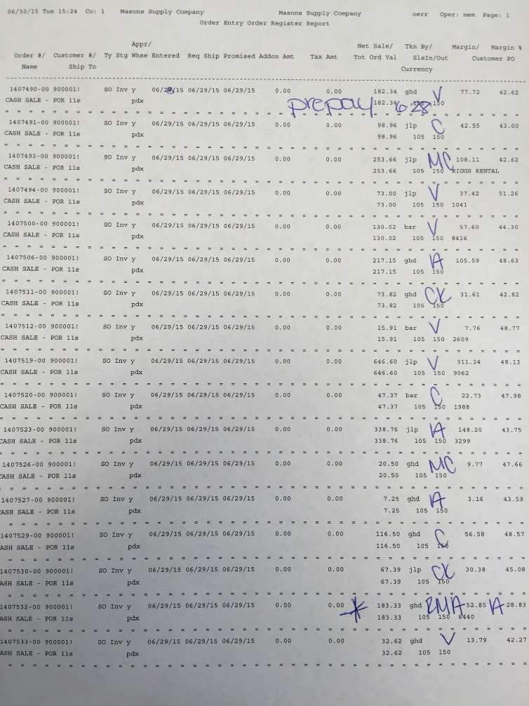

**Screen shots of OERR:**

1. Run OERR
2. New One-Time
3. Next
4. 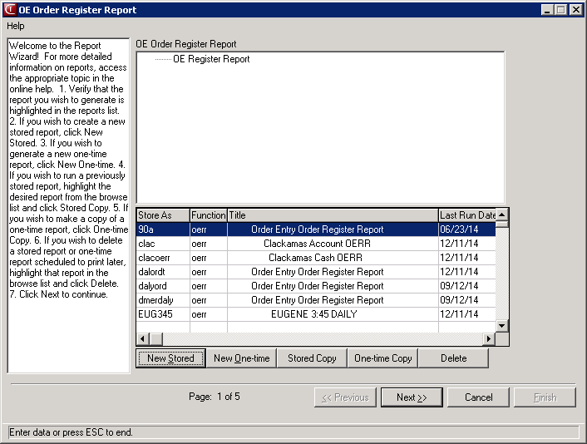
5. Select method of printing
6. Check “Print Options Page”
7. Next
8. 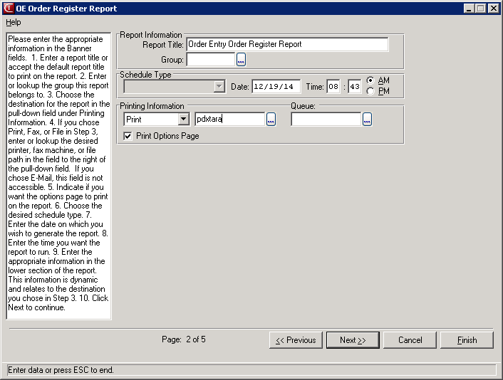
9. Only put in **“Customer Number”** and **“Invoice Date”**
   1. **Customer Number is your branch**

**900000- Employee Sale**

**900001- PDX**

**900002- Woodinville**

**900005- Salem**

**900006- Hillsboro**

**900007- Kingdom (Seattle)**

**900009- Clackamas**

**9000010- Tacoma**

**900012- Eugene**

**900013- Medford**

**900018- Ridgefeild**

**900017- West Eugene**

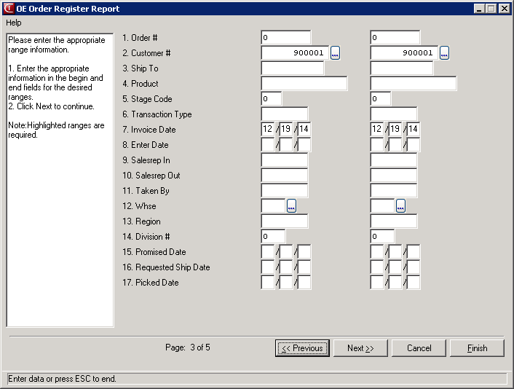

1. **Print Line Items: No**
2. **Next**
3. 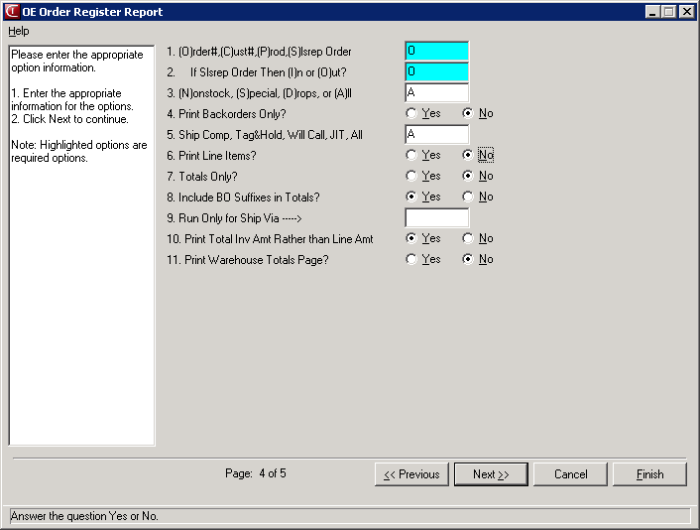
4. **Finish**
5. 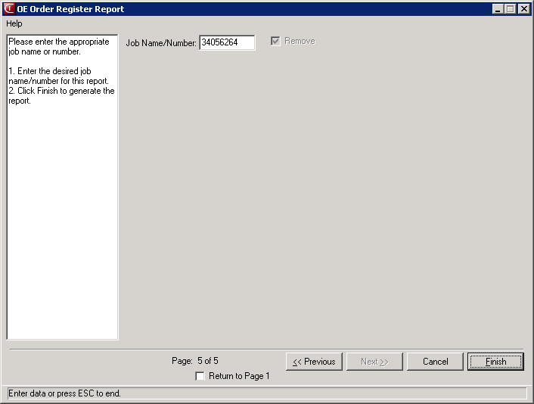

**Calculating OERR:**

**A(Net Sales) + B(Sales Tax) + C(Add On)= Your OERR Total**

Tot Ord Val note: If you use this column and do not calculate the Daily Sales per below, you could be adding amounts associated with back orders, prepays, etc.

The Total Sales for the below example: (15,254.93 + 998.07 + 216.25 = 16,469.25)

C

BA

C

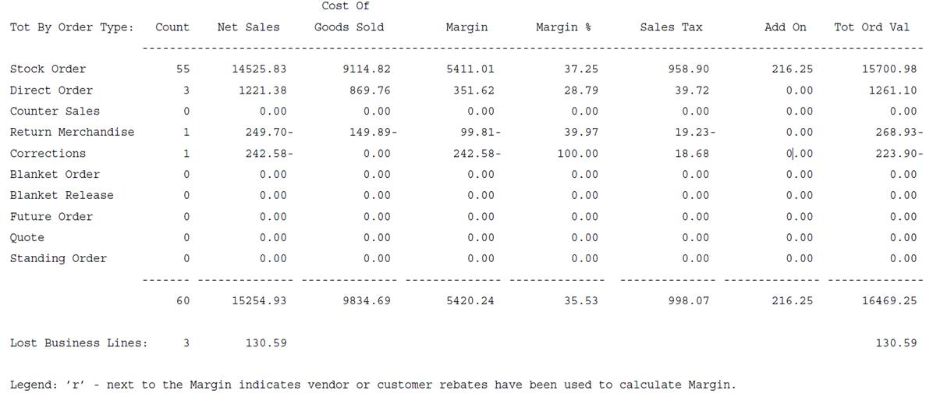

**Acknowledgment**

**By signing this document I am acknowledging that I have read and fully understand the “Daily Cash Sales” SOP.**

|  |  |  |
| --- | --- | --- |
|  |  |  |
| **Print Name** |  | **Date** |
|  |  |  |
| **Signature** |  |  |