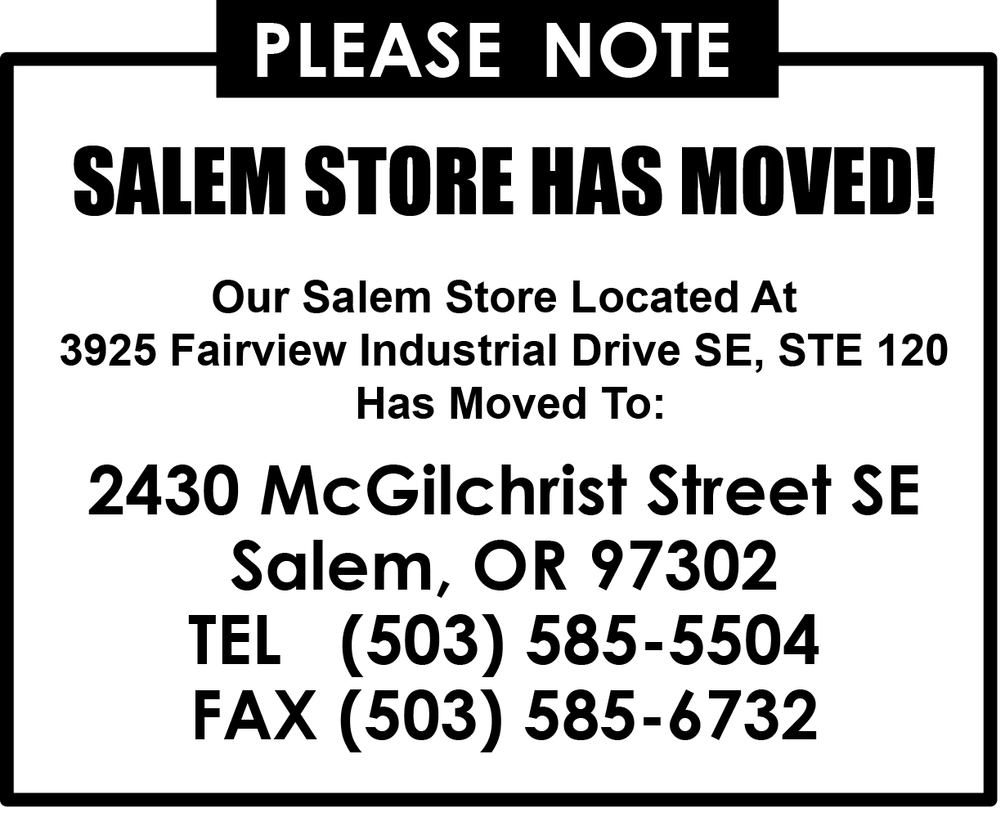 FAX
Portland, OR Woodinville, WA
(503) 234-4321 (425) 487-6161
(800) 537-3407 (800) 537-6216
To: |  | From:
Company: |  | Pages:
Fax: |  | Date:
Phone: |  | CC:
Re:

Urgent | For Review | Please Comment | Please Reply | Please Recycle

Message:

This fax sent by: | ____________________________________________ | From the following Masons Supply Office:

 | Location | Address | Phone | Fax
 | Portland | 2637 SE 12th Ave, Portland, OR 97202 | 503-234-4321 | 503-234-5606
 | Clackamas | 14670 SE 82nd Drive, Clackamas, OR 97015 | 503-722-1528 | 503-722-1569
 | Eugene | 1485 Glenwood Blvd, Eugene, OR 97403 | 541-744-6696 | 541-744-2302
 | West Eugene | 555 Commercial St, Ste A, Eugene, OR 97402 | 541-683-1408 | 541-683-1956
 | Hillsboro | 21535 NW Cherry Lane, Hillsboro, OR 97124 | 503-533-0107 | 503-533-0407
 | Medford | 2036 Lars Way, Medford, OR 97501 | 541-772-6161 | 541-772-4752
 | Port Orchard | 1525 Vivian Ct, Ste 150, Port Orchard, WA 98367 | 360-876-6372 | 360-876-6373
 | Ridgefield Form Yard | 7707 S. Union Ridge Parkway, Ridgefield, WA 98642 | 360-887-4777 | 360-887-3048
 | Salem | 2430 McGilchrist Street SE, Salem, OR 97302 | 503-585-5504 | 503-585-6732
 | Seattle | 115 S. Dawson St, Seattle, WA 98108 | 206-767-4645 | 206-767-4696
 | Tacoma | 2506 - 104th St Ct S., Ste B, Lakewood, WA 98499 | 253-581-6161 | 253-588-4272
 | Wilsonville | 10955 SW Commerce Cir, Ste E, Wilsonville, OR 97070 | 503-582-9320 | 503-582-8324
 | Woodinville | 6018 - 234th St SE, Ste A, Woodinville, WA 98072 | 425-487-6161 | 425-402-3676

