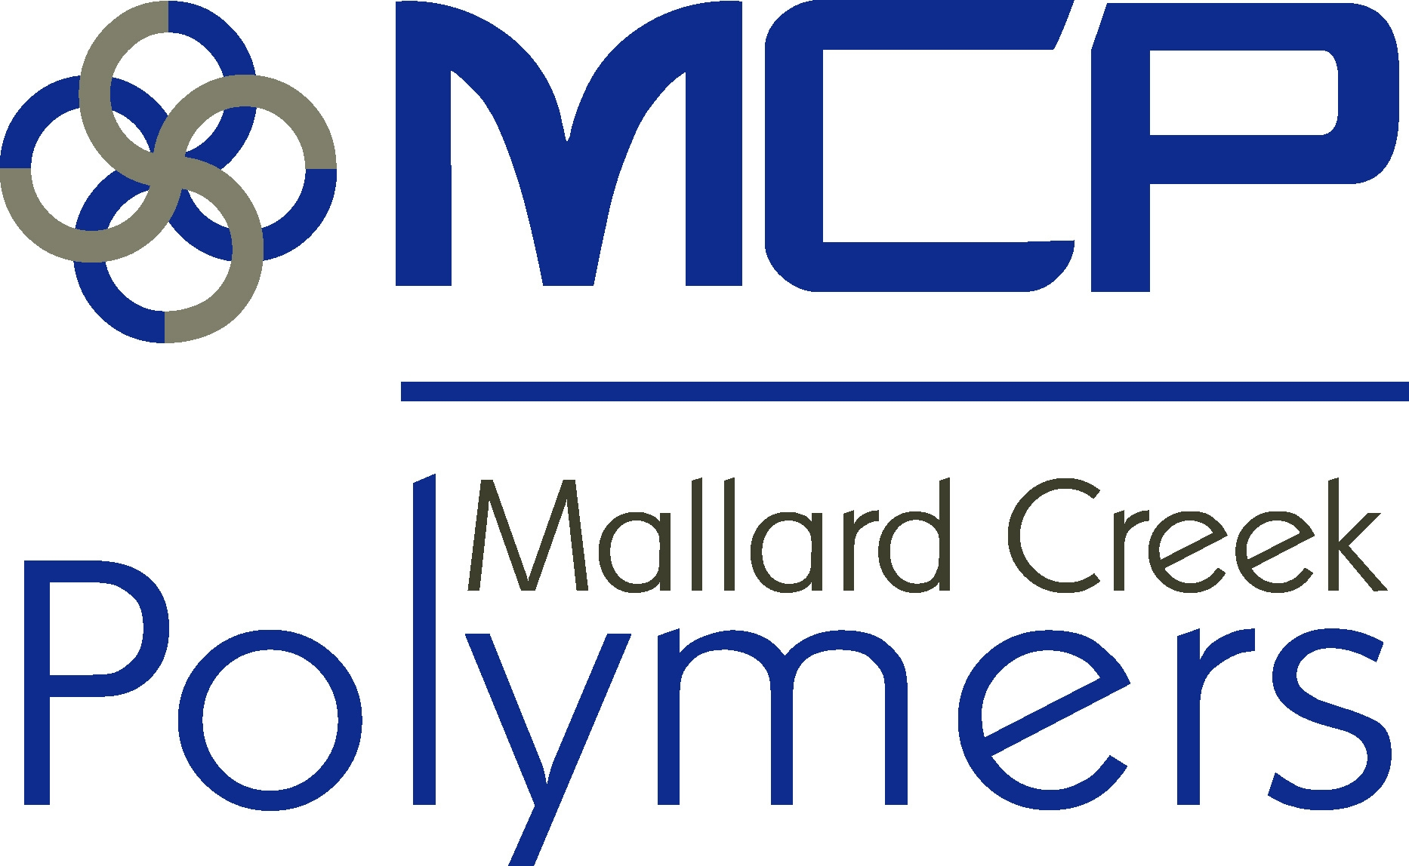

**MATERIAL SAFETY DATA SHEET**

Effective Date: 10/3/2011

**Product: ROVENE® 4042**

**1.** **Chemical Product and Company Identification**

**Product name:** ROVENE® 4042

**Chemical product name:** Anionic Emulsion of Carboxy Modified Styrene Butadiene Polymer

**Product code: none HMIS**

|  |  |
| --- | --- |
| Health: | 1 |
| Flammability: | 0 |
| Reactivity: | 0 |
| Personal Protection: |  |

**Manufacturer Name:** **Information Contact:**

Mallard Creek Polymers, Inc. Rob Beyersdorf

14800 Mallard Creek Rd Mallard Creek Polymers

Charlotte, NC 28262 14800 Mallard Creek Rd

Charlotte, NC 28262 **NFPA**

|  |  |
| --- | --- |
| Health: | 1 |
| Flammability: | 0 |
| Reactivity: | 0 |

1-704-547-0622 Ext 1006

**Emergency phone number:**

1-800-424-9300 or 1-703-527-3887 (CHEMTREC)

**2.** **Composition / information or ingredients**

**Chemical name:**

**CAS No. % by Wt. EC Number Symbol R-Phrases**

1) Carboxylated SBR emulsion Proprietary 49.0 – 51.0% unknown not controlled not controlled

2) Water 7732-18-5 49.0 - 51.0% unknown not controlled not controlled

**Additional Information**

Refer to Section 8 for exposure guidelines and Section 15 for regulatory information.

**3.** **Hazards identification**

Emergency Overview

The health hazards of this product should be low under normal industrial and commercial uses.

**Potential Health Effects**:

EYES: Contact may cause eye irritation.

SKIN: Prolonged or repeated contact may cause skin irritation.

INHALATION: Inhalation of vapor or mist can cause the following: headache and nausea, irritation of the eyes, nose, throat, and lungs.

Page: 1/5

INGESTION: Ingestion is not considered a potential route of exposure. If swallowed, give 2 glasses of water to drink. Consult a physician. Never give anything by mouth to an unconscious person.

**4.** **First-aid measures**

# First-Aid measures

EYE CONTACT: Immediately flush eyes with plenty of water for at least 15 minutes. Get medical attention if irritation develops or persists.

SKIN CONTACT: Wash skin with soap and water. Get medical attention if irritation develops or persists.

INHALATION FIRST: If exposed to excessive levels of fumes, remove to fresh air. If breathing is difficult, give oxygen. Get medical attention.

INGESTION: Ingestion is not considered a potential route of exposure. If swallowed, immediately give 2 glasses of water. Get medical attention immediately. Never give anything by mouth to an unconscious person.

**5.** **Fire-fighting measures**

PROPERTIES

COC Flash Point: N/A

Autoignition Temperature: N/A

FLAMMABLE LIMITS IN AIR

LEL: N/A

UEL: N/A

EXTINGUISHING MEDIA:

Use extinguishing media appropriate for surrounding fire.

FIRE & EXPLOSION HAZARDS:

Heating above 200°C or in fire conditions toxic decomposition products may be formed. Material can splatter

above 100C/212F. Polymer film can burn.

FIRE FIGHTING INSTRUCTIONS:

Avoid breathing smoke, fumes, and decomposition products. As in any fire, wear self-contained breathing

apparatus pressure-demand MSHA/NIOSH (approved or equivalent) and full protective gear.

**6.** **Accidental Release Measures**

**Personal Precautions:**

Splash goggles and gloves

**Environmental Precautions**

**And Clean-up Methods:**

Absorb with an inert material and put the spilled material in an appropriate waste disposal. Avoid run-off into sewers, ditches or waterways. Do not allow material to enter soil or surface water.

**7. Handling and storage**

RECOMMENDED STORAGE TEMPERATURE

Minimum: 1.0 C (33.8 F)

Maximum: 49.0 C (120.2 F)

Page: 2/5

HANDLING (PERSONNEL):

Monomer vapors can be evolved when material is heated during processing operations.

HANDLING (PHYSICAL ASPECTS):

Keep from freezing. Do not store at temperatures above 49°C. Avoid temperatures above 200°C.

STORAGE PRECAUTIONS:

Keep from freezing. Store in a cool place in original container and protect from sunlight. Keep container closed

when not in use.

**9. Engineering Controls, Personal Protection**

ENGINEERING CONTROLS:

Facilities storing or utilizing this material should be equipped with an eyewash facility and a safety shower.

Local exhaust ventilation may be necessary to control any air contaminants to within their TLVs during the use

of this product.

EYE / FACE PROTECTION REQUIREMENTS:

Where contact with this material is likely, eye protection is recommended.

SKIN PROTECTION REQUIREMENTS:

Selection of specific items such as gloves, boots, apron or full-body suit will depend on operation. Nitrile rubber

and PVC are not suitable protective materials; Neoprene is recommended.

RESPIRATORY PROTECTION REQUIREMENTS:

When there is potential for airborne exposures in excess of applicable limits, wear NIOSH/MSHA approved

respiratory protection.

EXPOSURE GUIDELINES:

No Information Available.

**9. Physical and chemical properties**

**Physical state:** Liquid

**Color:** White, milky

**Odor:** Slight, sweet odor

**Boiling Point:** 100C at 17mm Hg

**Melting Point:** 0ºC

**Vapor Density:** <1 (Air = 1)

**Vapor Pressure:** 17mm Hg @ 20C

**Solubility in water:** Miscible

**Specific Gravity:** 1.00 – 1.03

**pH:** 10.0 – 11.0

**10. Stability and reactivity**

STABILITY:

Materials containing similar structural groups are normally stable.

POLYMERIZATION:

This material is considered stable. Hazardous polymerization will not occur.

INCOMPATIBILITY WITH OTHER MATERIALS:

Page: 3/5

There are no known materials which are incompatible with this product.

DECOMPOSITION:

Decomposition will not occur if handled and stored properly. Avoid temperatures above 177oC/350oF, the onset

of polymer decomposition. Toxic decomposition products may be formed.

**11. Toxicological information**

MISCELLANEOUS:

Acute Data - No toxicity data are available for this material. The information shown is based on the toxicity of

properties of emulsion polymers

**12. Ecological information**

Persistence/degradability:Ecological information has not been determined for substance

Ecotoxicity:

**13. Disposal considerations**

Disposal / product:

Waste must be disposed in accordance with federal, state and local environmental control regulations.

Waste code:

Not available

Disposal / contaminated packaging:

Contaminated packaging should be emptied as far as possible andafterappropriate cleansing may be taken

for reuse.

**14. Transport information**

Department of Transportation (DOT) – US

This product is not regulated by D.O.T. when shipped domestically by land.

Transportation of Dangerous Goods (TDG) – Canada

This product is not regulated by TDG when shipped domestically by land.

**15. Regulatory information**

This material or all of its components are listed on the Inventory of Existing Chemical Substances under the Toxic Substance Control Act (TSCA).

This material or all of its components are listed on the Canadian Domestic Substances List (DSL).

This material or all of its components are listed (or considered as having been notified) on the European Inventory of Existing Chemical Substances (EINECS).

SARA, Title III, Section 313, No Components Listed.

Comprehensive Environmental Response, Compensation and Liability Act (CERCLA) - This product is not subject to reporting requirements under CERCLA.

Page: 4/5

### HISTORY

**16. Other information**

**Date of issue: 10/3/2011**

**Date of Previous Issue: 11/07/2007**

**Version: 3**

### Notice to Reader

To the best of our knowledge, the information contained herein is accurate. However, neither the above named supplier nor any of its subsidiaries assumes any liability whatsoever for the accuracy or completeness of the information contained herein. Final determination of suitability of any material is the sole responsibility of the user. All materials may present unknown hazards and should be used with caution. Although certain hazards are described herein, we cannot guarantee that these are the only hazards that exist.

Page: 5/5