
__________________________________________________________________________________________
Toll Free: (888) 833-8308 Durajoint Concrete Accessories
Fax: (330) 527-2440 10426 Industrial Drive
Web: www.durajoint.com Garrettsville, OH 44231

Ribbed with Centerbulb Waterstop
Type 13

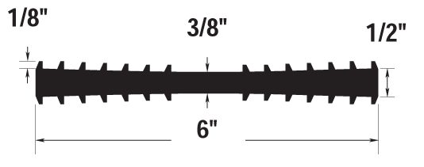

Weight: (lbs/ft) 1.59 ______ ________________________
Width: 6” _______
Thickness: 3/8” Flare ____ Head Pressure: (Ft) 200_

Typical Properties

CRD-C 573: Tensile Strength 1925 psi – 13.3 MPa
CRD-C 573: Ultimate Elongation 402%
CRD-C 571: Stiffness in Flexure 775 psi
ASTM D-624: Tear Resistance 380 lbs. /in.
ASTM D-1149 Ozone Resistance passed
CRD-C 570: Low Temperature - No Cracking, Brittleness (-35°F) or Splitting
CRD-C 572: Accelerated Extraction
Ultimate Elongation 366% Par 7.1
Tensile Strength 1825 psi Par 7.1
CRD-C 572: Effects of Alkalies Loss in Weight
0.10% Max. Par 7.2
Gain in Weight 0.25% Max.

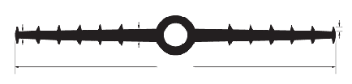
1/4”
1/2”
12”
3/16”
7/8 ID & 1-1/2” OD

Waterstop • Forming Accessories • Rebar Supports • Mesh Supports • Prestressed Accessories

