
__________________________________________________________________________________________
Toll Free: (888) 833-8308 Durajoint Concrete Accessories
Fax: (330) 527-2440 10426 Industrial Drive
Web: www.durajoint.com Garrettsville, OH 44231
Post Applied Durajoint Type 18 TPER Kit

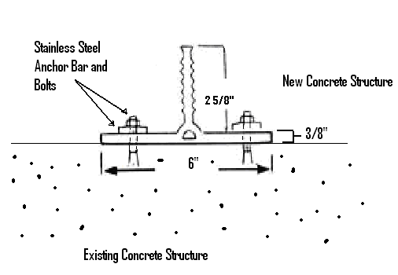
All waterstop shall be Durajoint PVC Waterstop as manufactured by Durajoint.
It shall be an extrusion of chemically resistant thermal elastomeric rubber and additional
resins, plasticizers and stabilizers which meet or exceed the requirements of the
Corps of Engineers specifications. Types and dimensions of waterstop shall be
those shown in the project specifications.
Typical Properties
ASTM D-412: Tensile Strength Min. 1800 psi ASTM D-412: Ultimate Elongation Min. 450%
ASTM D-624: Tear Resistance 278 lbs. /in. ASTM D-2240 Hardness Max. 80 min.
ASTM D-792 Specific Gravity 0.96 min. ASTM D-570 Water Absorption Max. 0.15%
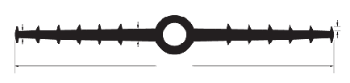
ASTM D-1171 Ozone Resistance 450 ASTM D-412 100% Modulus 1000 psi ASTM D-746: Low Temperature - No Cracking, Brittleness (-75°F) or Splitting
1/4”
1/2”
12”
3/16”
7/8 ID & 1-1/2” OD
Description:
Post Applied Durajoint was created to enable to attach a new concrete structure to an existing concrete structure, providing a water tight joint.
Application:
Surface of concrete where Post Applied Durajoint will be placed, must be smooth and sound. Beads of Durajoint RTV 7500 Silicone should be applied to the concrete surface near to the anchor bolts in full length.

Place the Post Applied Durajoint into the desired position, then fasten by using the anchor bolts and the stainless steel bars as supplied by Durajoint Concrete Accessories.

Placement: Batten Bar side edge should be placed ½” in from edge of waterstop.

Each kit contains: 2) -Stainless Steel batten bars measuring 10’ x 1” x 1/8” –Each Bar has 20 pre-drilled placement holes along the length of the bar.
40)- Stainless Steel Anchors (1/4” x 2-1/4”) and Anchor Bolts.

Waterstop • Forming Accessories • Rebar Supports • Mesh Supports • Prestressed Accessories

