
__________________________________________________________________________________________
Toll Free: (888) 833-8308 Durajoint Concrete Accessories
Fax: (330) 527-2440 10421 Industrial Drive
Web: www.durajoint.com Garrettsville, OH 44231

Retro-Fit Type 18-9 Kit

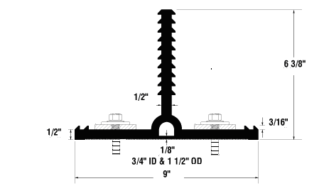

Description:
Post Applied Durajoint was created to enable to attach a new concrete structure to an existing concrete structure, providing a water tight joint.

Installation:

- The old concrete surface must be dry and clean. To achieve the proper surface preparation sandblasting and/or grinding will be required to insure adhesion of the attachment system.
- Apply a bed of W.R. Meadows Rezi-Weld Gel Paste Epoxy completely covering the prepared surface with a notched trowel approximately 1/8” wider than the retrofit waterstop base.
- Place the retrofit waterstop base against the bed of epoxy.
- Begin securing the retrofit waterstop base by drilling holes through the retrofit waterstop base into the existing concrete. Make sure the holes matches the stain steel baton bar hole pattern.
- Slide the provided self tapping screw through the pre-drilled baton bar hole and into the previous drilled base/concrete hole. Attach the top side of the retrofit waterstop base first, than attach the bottom.

Kit Content:
(2) Stainless Steel batten bars #304 - 10’ x 3” x 3/8” w/15 pre-drilled holes, (15) - 3”x 3/8” Stainless Steel Screw #410 (1) 22 oz. cartridges of W.R. Meadows Rezi-Weld Gel Paste

Waterstop • Forming Accessories • Rebar Supports • Mesh Supports • Prestressed Accessories

