
__________________________________________________________________________________________
Toll Free: (888) 833-8308 Durajoint Concrete Accessories
Fax: (330) 527-2440 10421 Industrial Drive
Web: www.durajoint.com Garrettsville, OH 44231

Retro-Fit Waterstop
Type 29 Kit

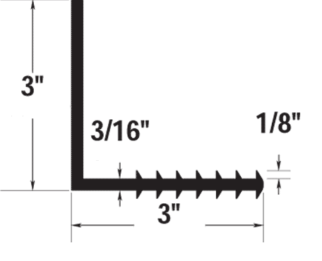
Weight: (lbs/ft) .82 1 – 10 ft. piece of Type 29
Width: 3” 1 – 10 ft. Stainless Baton Bar___
Thickness: 3/16” 10 – Stainless Steel Bolts & Epoxy
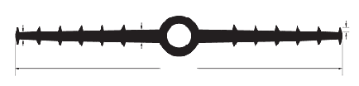
1/4”
1/2”
12”
3/16”
7/8 ID & 1-1/2” OD
Installation:

- The old concrete surface must be dry and clean. To achieve the proper surface preparation sandblasting and/or grinding will be required to insure adhesion of the attachment system.
- Apply a bed of W.R. Meadows Rezi-Weld Gel Paste Epoxy completely covering the prepared surface with a notched trowel approximately 1/8” wider than the retrofit waterstop base.
- Place the retrofit waterstop base against the bed of epoxy.
- Begin securing the retrofit waterstop base by drilling holes through the retrofit waterstop base into the existing concrete. Make sure the holes matches the stain steel baton bar hole pattern.
- Slide the provided self tapping screw through the pre-drilled baton bar hole and into the previous drilled base/concrete hole. Attach the top side of the retrofit waterstop base first, than attach the bottom.

Waterstop • Forming Accessories • Rebar Supports • Mesh Supports • Prestressed Accessories

