
__________________________________________________________________________________________
Toll Free: (888) 833-8308 Durajoint Concrete Accessories
Fax: (330) 527-2440 10426 Industrial Drive
Web: www.durajoint.com Garrettsville, OH 44231

Durajoint Type 29A Kit

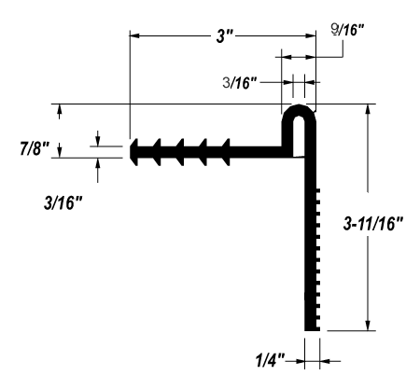
Weight: (lbs/ft) 1.55 _____________________
Width: 3” _____________________
Thickness: 3/16” _____________________

Kit Includes:
1-10ft piece of Type 29A Waterstop
1-10ft Stainless Steel Bar
20- Stainless Steel Bolts and Anchors
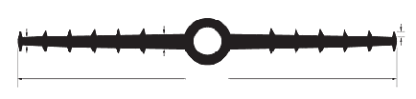
1/4”
1/2”
12”
3/16”
7/8 ID & 1-1/2” OD

Waterstop • Forming Accessories • Rebar Supports • Mesh Supports • Prestressed Accessories

