
__________________________________________________________________________________________
Toll Free: (888) 833-8308 Durajoint Concrete Accessories
Fax: (330) 527-2440 10421 Industrial Drive
Web: www.durajoint.com Garrettsville, OH 44231

Ribbed with Centerbulb Waterstop
Type 3 TPER

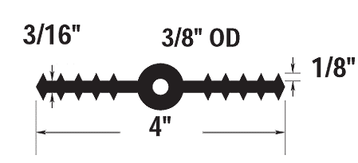

Weight: (lbs/ft) .59 I.D. Diameter:
Width: 4” O.D. Diameter: 3/8”_____
Thickness: 3/16” Head Pressure: (Ft) 65_
Tolerances: +/- 1/16” ___________________________

All waterstop shall be Durajoint TPER Waterstop as manufactured by Durajoint.
It shall be an extrusion of chemically resistant thermal elastomeric rubber and additional
resins, plasticizers and stabilizers which meet or exceed the requirements of the
Corps of Engineers specifications. Types and dimensions of waterstop shall be
those shown in the project specifications.

Typical Properties

ASTM D-412: Tensile Strength Min. 1800 psi
ASTM D-412: Ultimate Elongation Min. 450%
ASTM D-624: Tear Resistance 278 lbs. /in.
ASTM D-2240 Hardness Max. 80 min.
ASTM D-792 Specific Gravity 0.96 min.
ASTM D-570 Water Absorption Max. 0.15%
ASTM D-1171 Ozone Resistance 450
ASTM D-412 100% Modulus 1000 psi
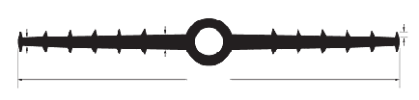
ASTM D-746: Low Temperature - No Cracking, Brittleness (-75°F) or Splitting
1/4”
1/2”
12”
3/16”
7/8 ID & 1-1/2” OD

Waterstop • Forming Accessories • Rebar Supports • Mesh Supports • Prestressed Accessories

