
__________________________________________________________________________________________
Toll Free: (888) 833-8308 Durajoint Concrete Accessories
Fax: (330) 527-2440 10426 Industrial Drive
Web: www.durajoint.com Garrettsville, OH 44231

Split Ribbed with Centerbulb
Durajoint Type 300 TPER

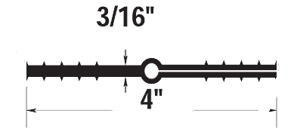

Weight: (lbs/ft) .50 TPER Chemical Resistant Material___
Width: 4” Bulb Thickness:________
Thickness: 3/16” Head Pressure: (Ft) 65__

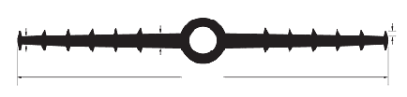
1/4”
1/2”
12”
3/16”
7/8 ID & 1-1/2” OD

Waterstop • Forming Accessories • Rebar Supports • Mesh Supports • Prestressed Accessories

