
__________________________________________________________________________________________
Toll Free: (888) 833-8308 Durajoint Concrete Accessories
Fax: (330) 527-2440 10421 Industrial Drive
Web: www.durajoint.com Garrettsville, OH 44231

Baseal
Type 320

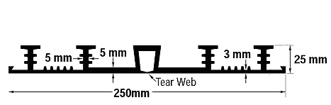

Weight: (lbs/ft) 1.95__________________________
Width: 250mm_______________________________
Thickness:5mm/3mm ___________________________

All waterstop shall be Durajoint PVC Waterstop as manufactured by Durajoint.
It shall be an extrusion of virgin polyvinyl chloride and additional resins, plasticizers
and stabilizers which meet or exceed the requirements of the Corps of Engineers
specifications. Types and dimensions of waterstop shall be those shown in the
project specifications.

Typical Properties

CRD-C 573: Tensile Strength 1925 psi – 13.3 MPa
CRD-C 573: Ultimate Elongation 402%
CRD-C 571: Stiffness in Flexure 775 psi
ASTM D-624: Tear Resistance 380 lbs. /in.
ASTM D-1149 Ozone Resistance passed
CRD-C 570: Low Temperature - No Cracking, Brittleness (-35°F) or Splitting
CRD-C 572: Accelerated Extraction
Ultimate Elongation 366% Par 7.1
Tensile Strength 1825 psi Par 7.1
CRD-C 572: Effects of Alkalies Loss in Weight
0.10% Max. Par 7.2
Gain in Weight 0.25% Max.

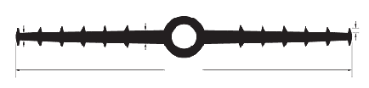
Waterstop • Forming Accessories • Rebar Supports • Mesh Supports • Prestressed Accessories
1/4”
1/2”
12”
3/16”
7/8 ID & 1-1/2” OD

